The Beef Experience
You’ll be guided the very best of Hereford Prime Beef by our Chef, table side
€75
€75.00

Malbec wine pairing €35

BEEF CARPACCIO
Irish Hereford Prime fillet, crisp shallots, parmesan, truffle oil

Hilario Malbec, Cahors, France 2017

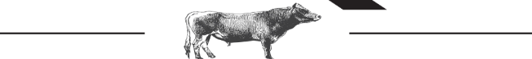

ROAST BONE MARROW
Sour dough toast, citrus segments, radish

Malbec La Mascota, Mendoza, Argentina 2018

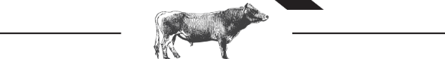

Three Cuts of Hereford Prime Sharing Boards
8oz / 227g Fillet, prime centre cut
9oz / 25 Sirloin, on the bone
12oz / 340g Rib-eye *World Steak Gold Medal Winner*

Sharing boards are served with greek salad, Ballymakenny pink fir potatoes, peppercorn brandy cream, dijon & béarnaise

Amancaya, Malbec, Mendoza, Argentina 2017

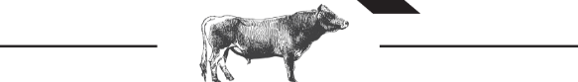

IRISH CHEESE SELECTION
A Few of the amazing cow’s milk cheese Ireland has to offer
Spiced poached pear

Terrazas de los Andes, Mendoza, Argentina 2017

